Project Design Phase
Solution Architecture

Date | 29 Jun 2025
Team ID | LTVIP2025TMID47516
Project Name | iRevolution: A Data-driven Exploration of Apple's iPhone Impact in India using Tableau
Maximum Marks | 4 Marks

Solution Architecture:
Problem Focus: Lack of clear, data-driven insights on iPhone adoption, user behavior, and cultural impact in India.
Data Collection:
- Sales, demographics, and simulated social media sentiment data.
- Stored and managed in IBM DB2.
Data Preparation:
- Cleaned using SQL and Python (Pandas, TextBlob).
- Processed for trend, sentiment, and preference analysis.
Visualization Layer:
- Built using Tableau for interactive dashboards.
- Includes trends, demographics, and cultural impact visualizations.
Web Integration:
- Dashboards and stories embedded into a Flask-based web UI.
- Enables accessible viewing and interaction for users.
Scalable Design:
- Can be extended with real-time data and adapted to other markets or products

Example - Solution Architecture Diagram:

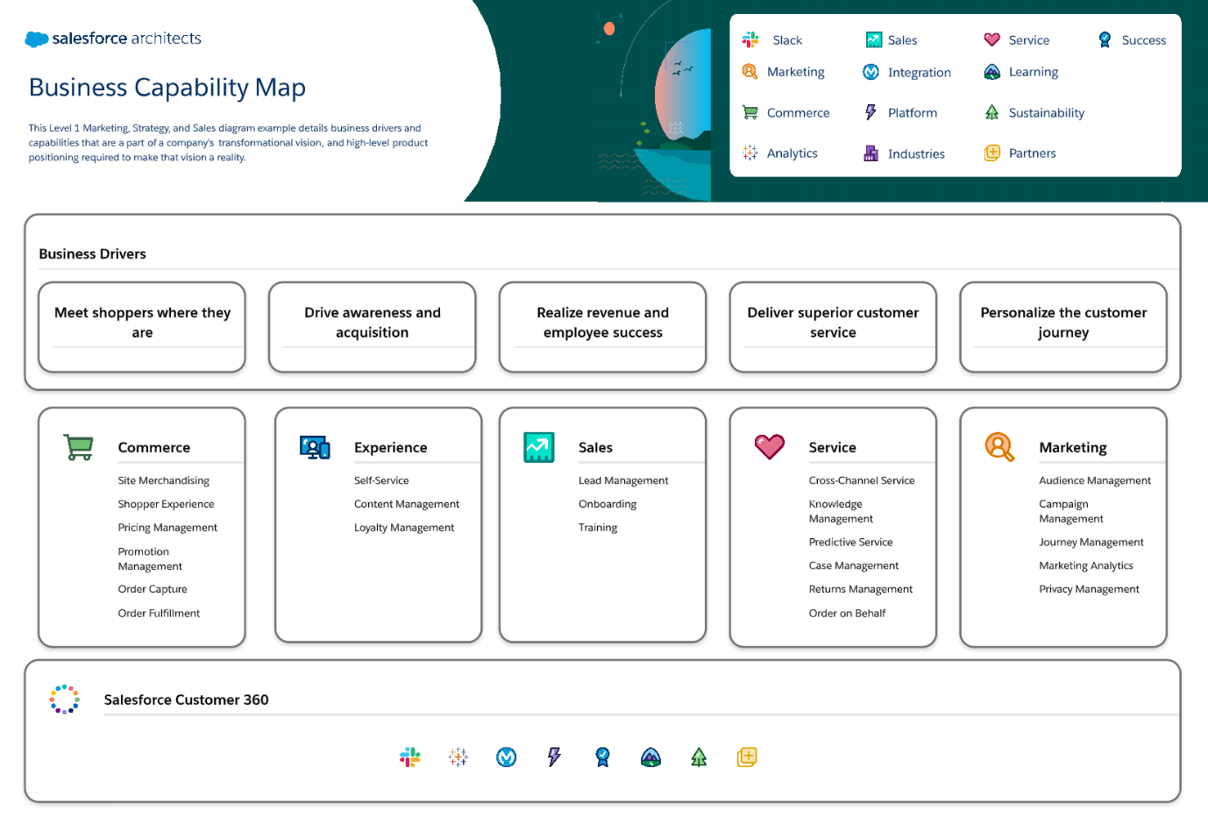
Figure 1: Architecture and data flow of iPhone sales in india

